Redis Database – Remote Directory Server
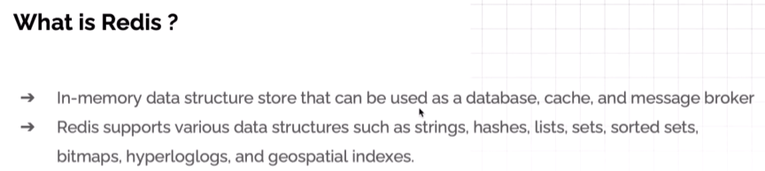
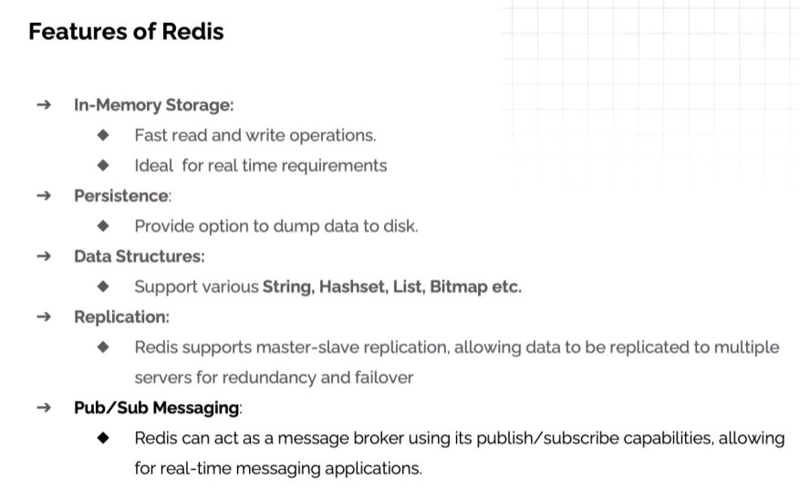

Redis Architecture
It works on client server architecture. We have a Redis Server (Master) where all the data is present and all commands run on this server. But no one can directly use the Redis server, we need a Client (Slave).
Client sends the command/request to the Redis Server. Command is then processed on Redis server and its response is sent back to the Client.
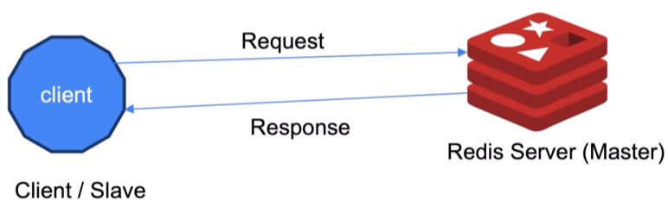
Client can be CLI or GUI or our application can also act as a client to run commands on redis server.

In Redis, Keys are always String but Values have types –
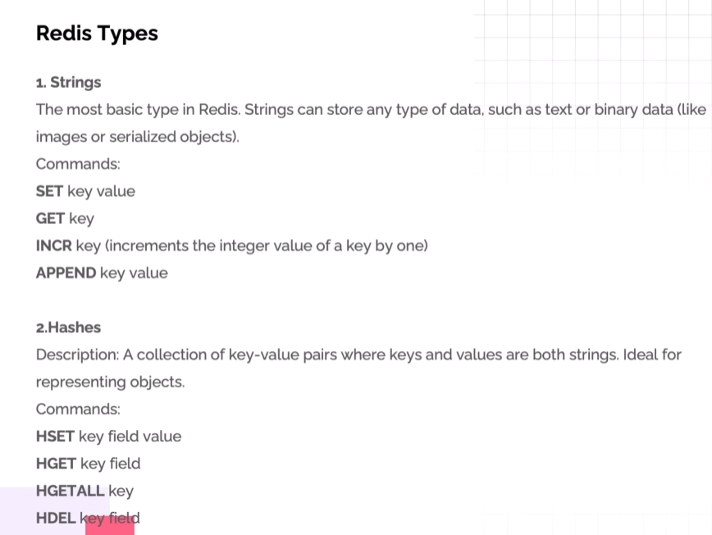
Redis String can hold plain text, numbers, json, binary data, images, etc…
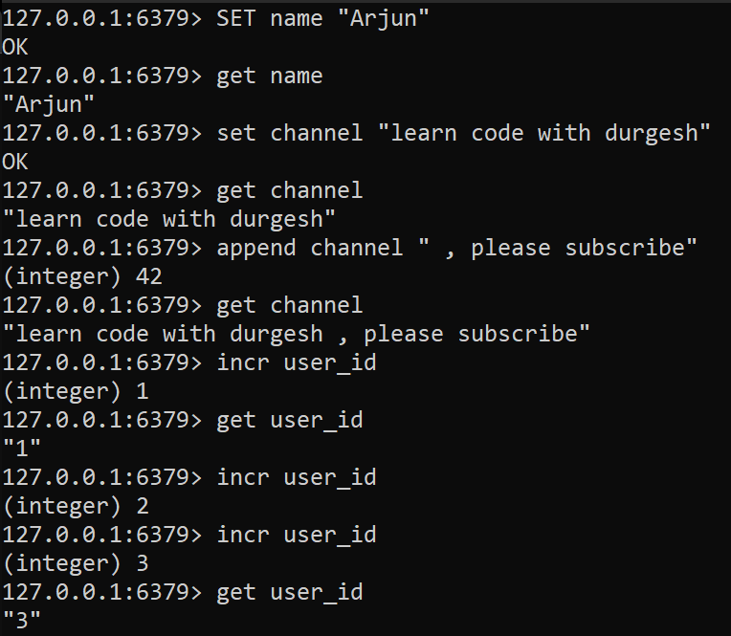
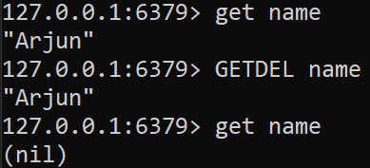 getdel will get and delete the key

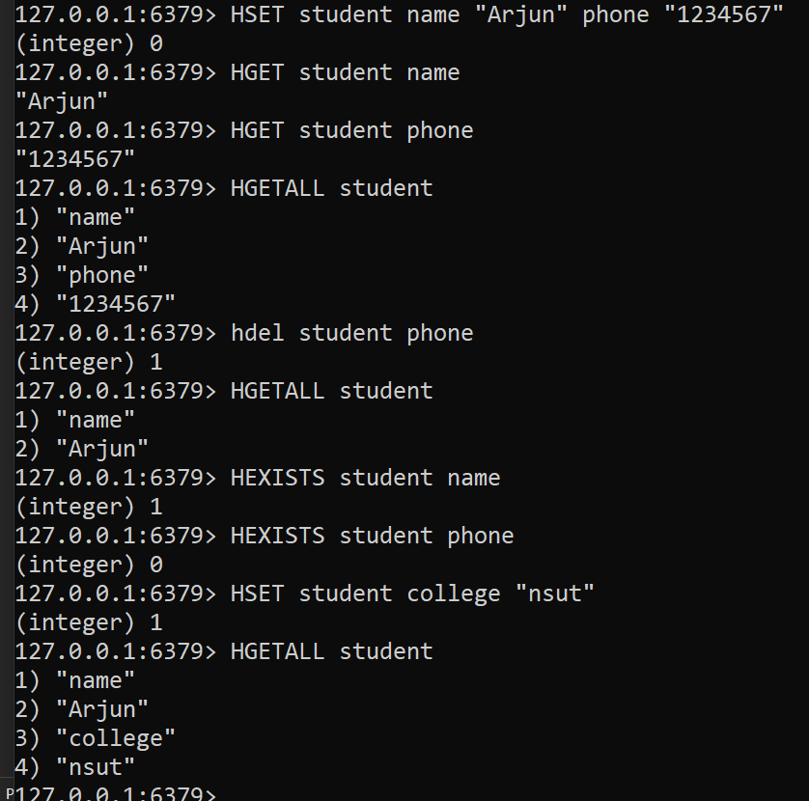
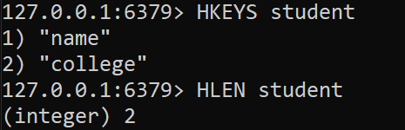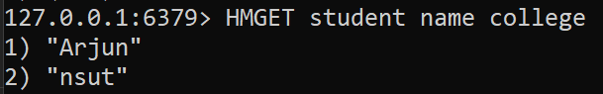

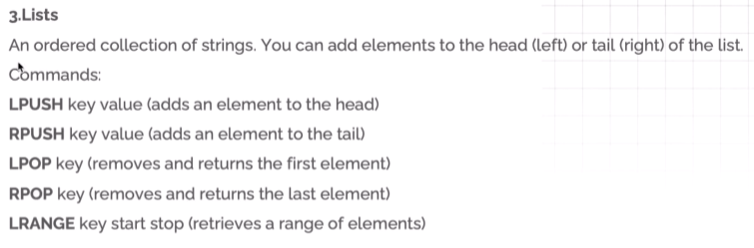
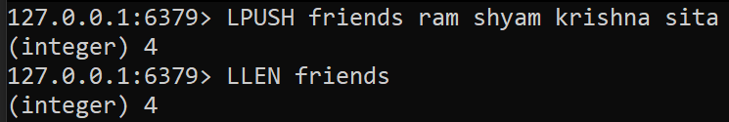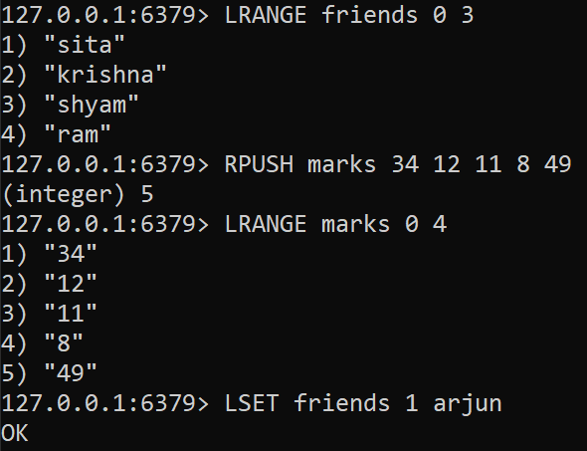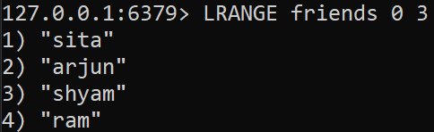
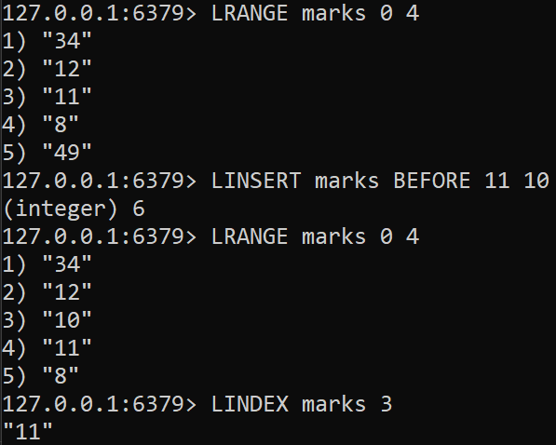
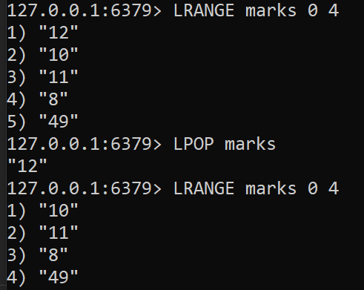
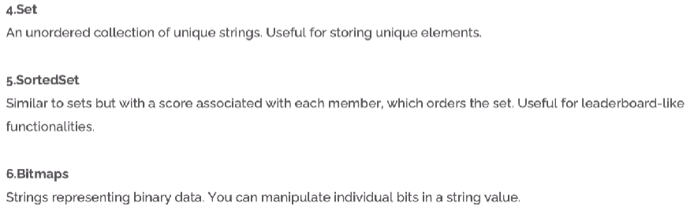
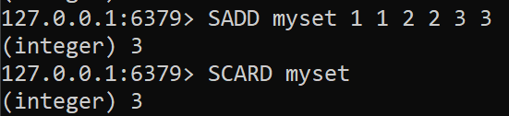

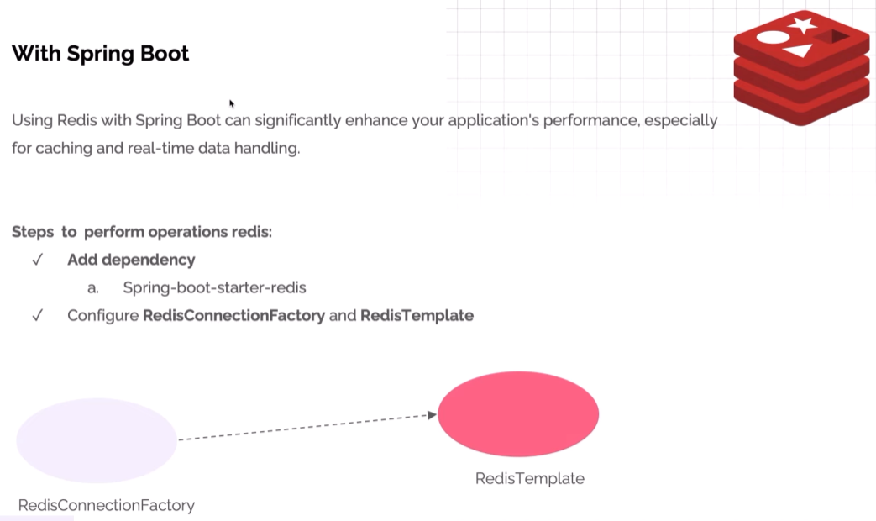
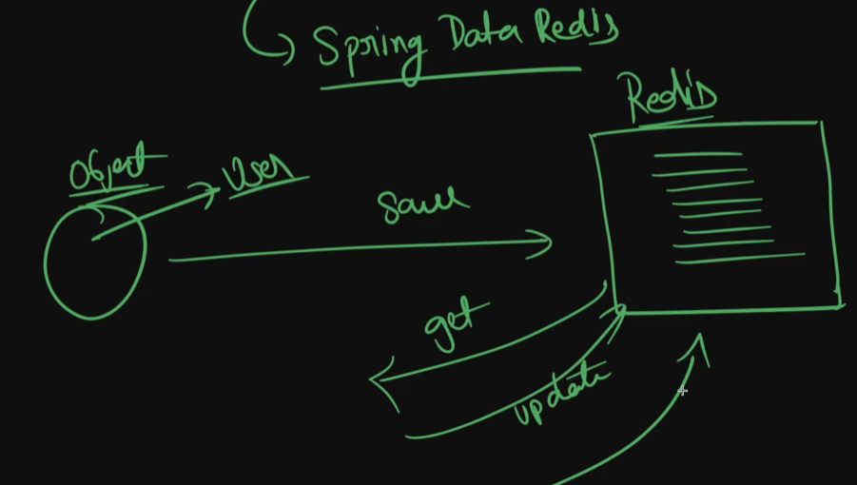
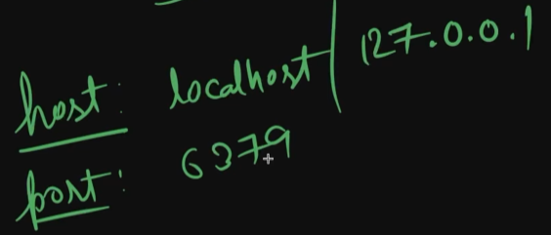
Using host + port our java app can connect with Redis Server running on our local machine.
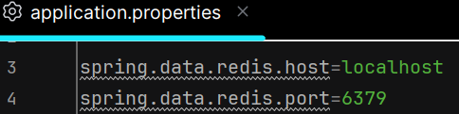
We need RedisTemplate object to perform operations so we’ll configure it so this object can be autowired anyplace when needed.
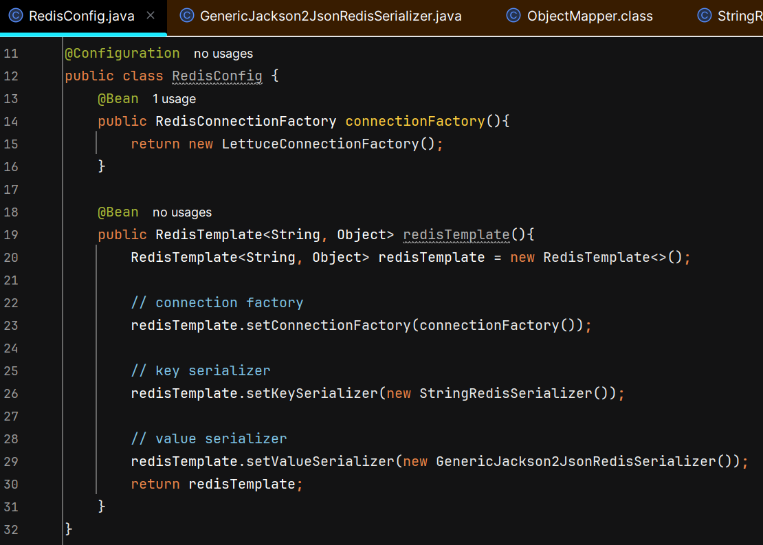
Redis internally stores everything as raw bytes.
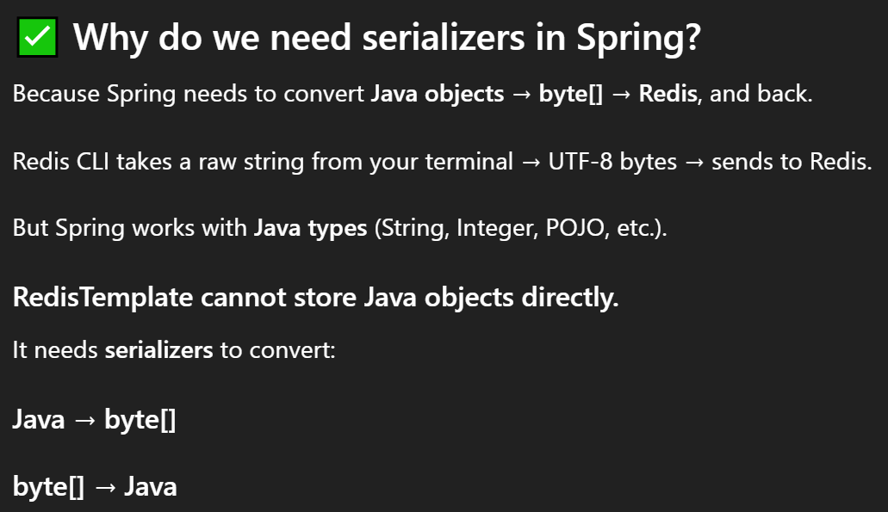

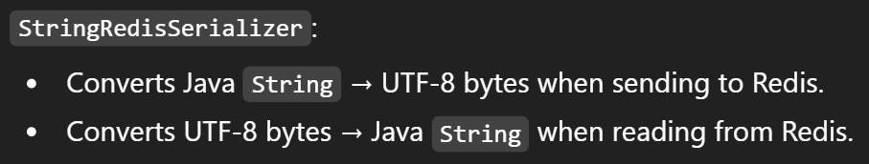
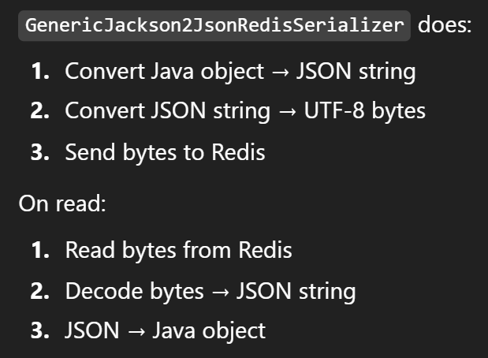
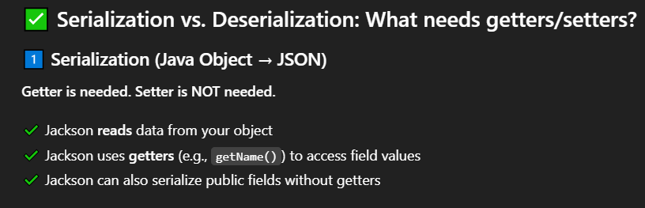
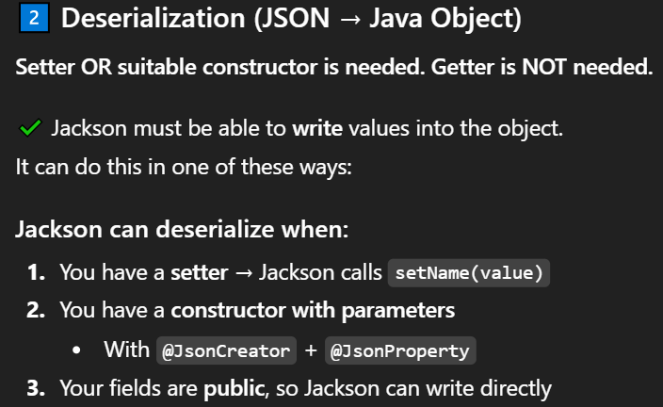
Note :- Private field annotated with @JsonProperty (getters and setters NOT needed)

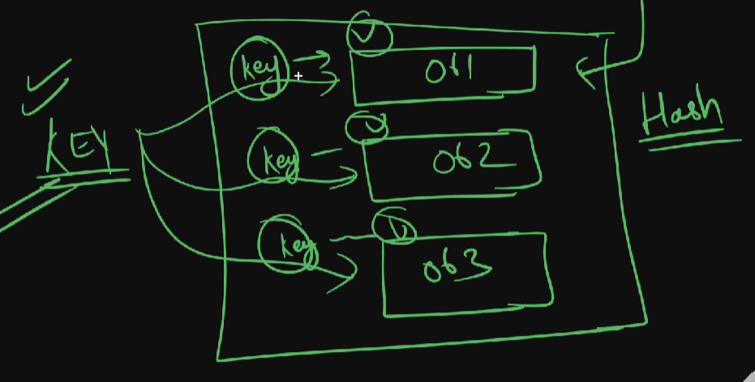
We are using Hash datastructure to store data
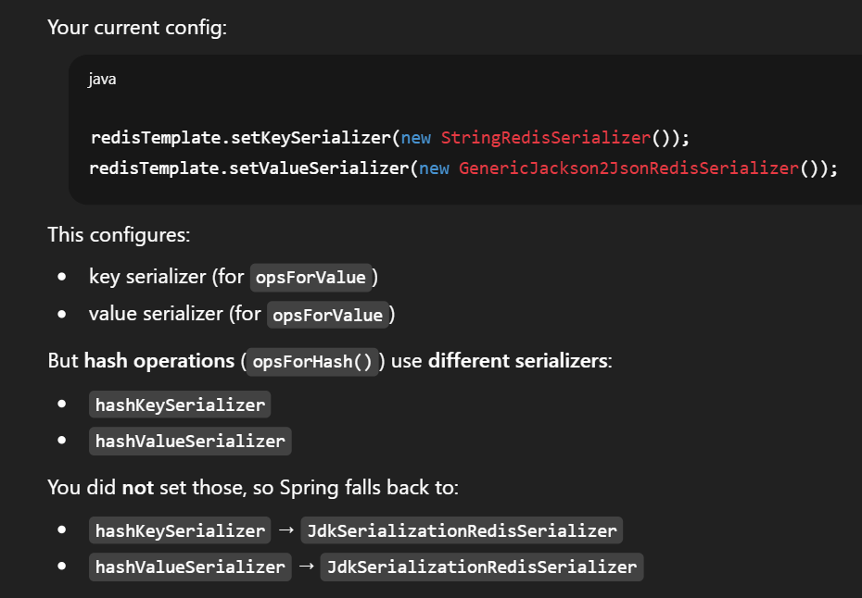
JdkSerializationRedisSerializer use Java native serialization (ObjectOutputStream) which only works with Serializable classes. So, we implented Serializable interface –
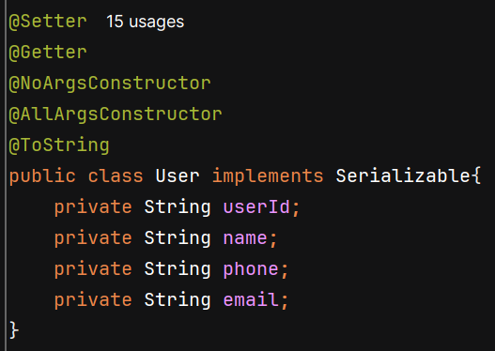
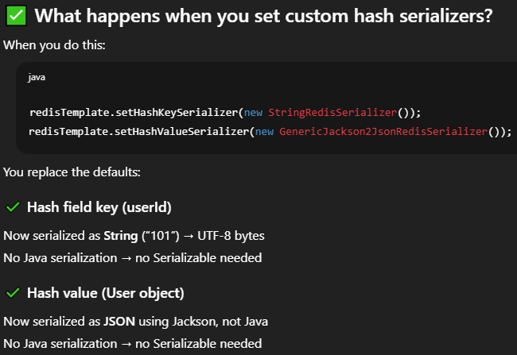
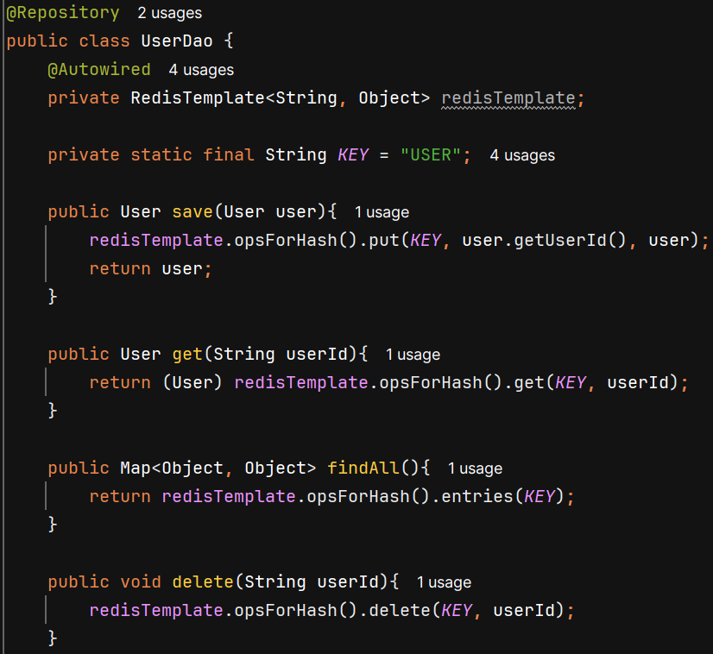
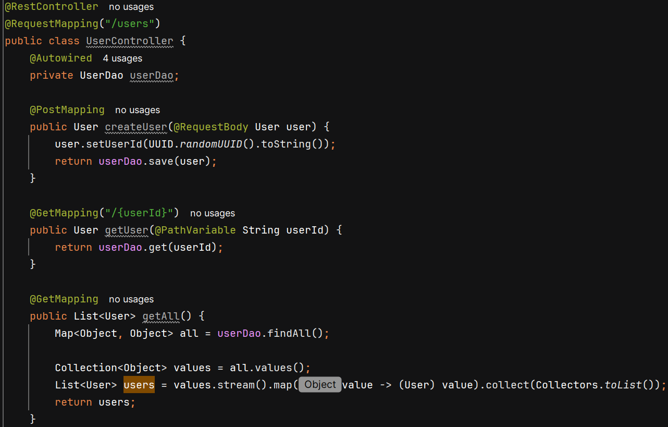

How to store java object for some value –
